 

# ACM, VISAKHAPATNAM GAME DEVELOPMENT – EVENT REPORT

## Summary

ACM, GITAM conducted the "GAME DEVELOPMENT" event. In this event, ACM collaborated with one of the best online learning platforms, i.e. Coding Ninjas. The event's speaker was Shantanu Shubham (Software engineer at Schlumberger). The event started with an introduction speech by Shantanu Shubham, sharing his insights regarding Game Development. The event was organized on 16/04/2022 from 11:00 AM to 12:30 PM on Zoom. The participants interacted with speakers through the Zoom platform. The speaker provided some tips to the participants about the field of game development.

The publicity and registrations for the event started seven days before the event, and students were sent the event's details through the club's official mail id. A WhatsApp message was circulated briefing about the event, and all the event details were mentioned there. The posters and videos regarding the event were shared on various social media handles such as Instagram and LinkedIn.

WhatsApp groups were created to engage with the participants. 173 attended the webinar.

By the end of the event, the speaker addressed the participants on various aspects of game development and interacted with the participants by posing some questions on career paths and prerequisite concepts of game development, which enlightened the attendees about the role of "Unity and Unreal Engine" in game development. He also addressed the industry's transitions and the importance of "Blender'' in game designing. The event helped the participants to gain knowledge. The speaker gave clear insights on choosing a career in game development. By the end of the webinar, the ambiguity in everyone’s mind regarding “gaming as a career” was cleared. Overall, it has been the most interactive session. Attendees appreciated the event, and the event was a great success.

# GAME DEVELOPMENT – EVENT REPORT

Photographs

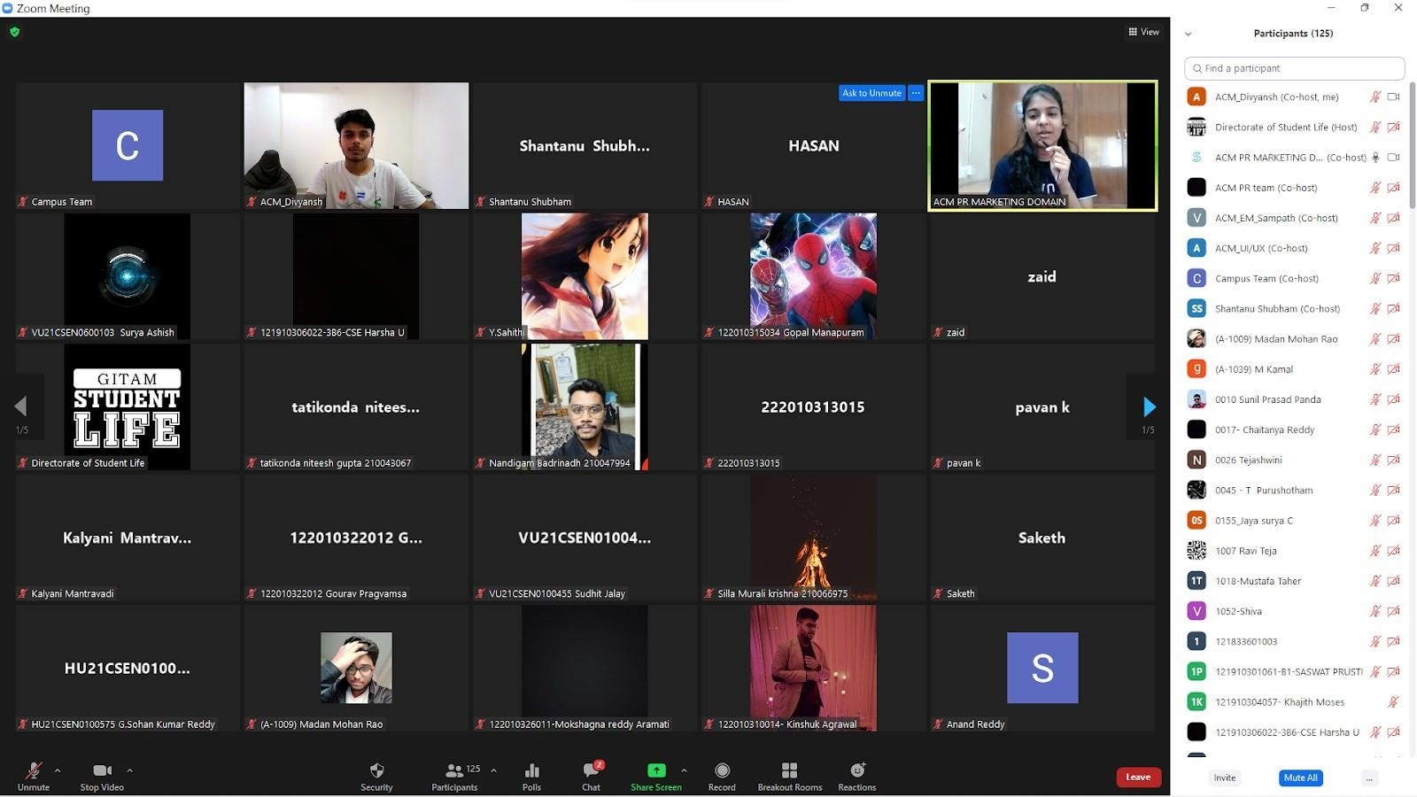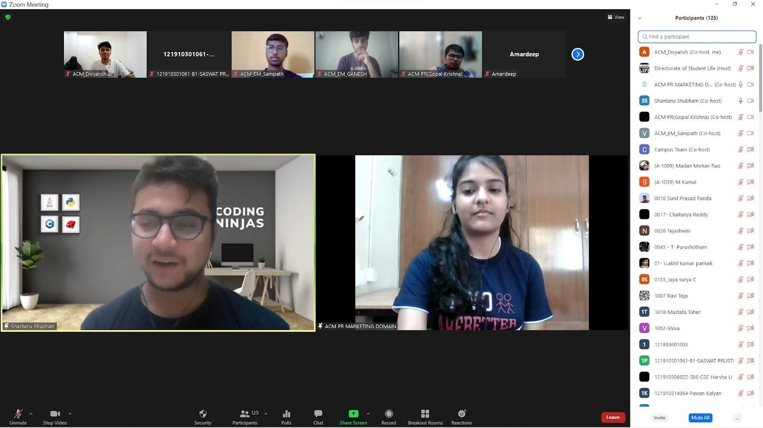



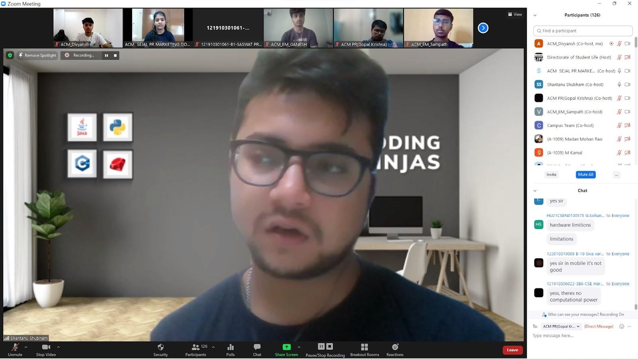

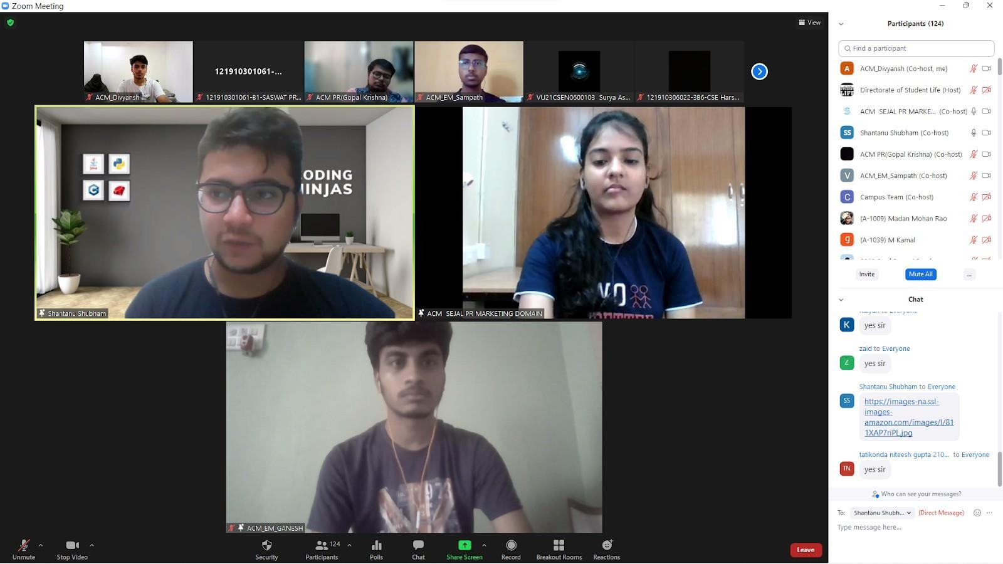



## Event Snapshot

|  |  |
| --- | --- |
| **EVENT SNAPSHOT** | |
| Event Name: | Workshop on Game Development |
| Organizing Club: | ACM |
| Event Date: | 16/04/2022 |
| Event Time: | 11:00 AM to 12:30 PM |
| Event Mode / Venue: | Online / Zoom |
| Social media reach: | Instagram: @gitam_acm  LinkedIn: https:/[/www.linkedin.com/company/acm](http://www.linkedin.com/company/acm)  -gitam-association-for-computing- machinery/mycompany/ |
| Registrations: | 293 |
| Number of Participants/Attendees: | 173 |
| Winners (if any): Name - Regd ID - Email ID | NA |
| Faculty - Judge - Guest Speaker: | Shantanu Shubham (Software engineer at Schlumberger) |
| Event Report Author - Designation: | Haravamsi - POC for Event Management & PR, ACM GITAM  Sampath - Event Management CoreTeam , ACM |